Practices and Lessons Learned
from Branding of Indonesian Education Institutions
through Open and Distance Learning (ODL)
Jaslin Ikhsan, Herman, Dian Susetyaningtyas

Abstract
Education is always needed by people, formally or informally. Knowledge as parts of items in education is also growing every day. The speed of knowledge growth can not be followed by classical way. People who are involved in education need to change the idea of delivering courses. Teachers/lecturers need to know the use of ICT in delivering their courses. By knowing the use of ICT, teachers/lecturers can ask their students to do the same thing to broader their knowledge. Many sources in web can be read as other references beside their own text books. Meanwhile, SEAMOLEC offers SEA EduNet as a system in delivering courses electronically. One teacher/lecturer can give lecture in one place and many students will receive in many places which connected to SEA EduNet. Interaction can be done by using Moodle with discussion, chatting, or e-mail. Two or more universities (multiversity) can collaborate in developing special program by using SEA EduNet. Many more students can involve in that program. Educational cost can be reduced up to 50%, and no new building is needed. The key is collaboration. Therefore, students who have financial problem can be enrolled the program in SEA EduNet.

A. Introduction
Education is a vital element of society. In day-to-day life, individuals have two choices: adapt or risk being replaced. In today’s economy, individuals not only have to obtain the necessary foundation skills and keep them current; they also need to acquire new knowledge and skills if they wish to maintain their status quo. The fast evolving pace of today’s business environment demands that its workers become lifelong learners. Lifelong learning is the process of individual learning across a person’s life span, from cradle to grave. Lifelong learning can occur in both a formal and an informal setting. A formal setting is provided by an educational institution. This is not only true for information technology professionals, but also for those who are expected to interact with the electronic and fully automated information systems available in one way or another (Richards & Garcia, 2006).
Dropped-out students also still need education in order to have certificates. However, even many people need schools and universities but still the numbers of schools and universities do not enough to receive or to serve all people who need education with classical way.
Basically, people who need knowledge can learn directly from books and practice what they have already learned. They can also receive degree by attending distance learning institution which delivers the course only by using written materials. Infact, students who registered in distance learning institution usually have problems attending face-to-face schools or universities. They are workers and usually work along the day. Many people also can not afford to pay tuition fee. But they need certificate showing that they have expertise in certain field. Clearly, this certificate can be used to promote their career. If the face-to-face educational institution can not serve these kinds of people, there should be an alternative way to help them.
The increasing number of people who needs education becomes problem in the world. The number of students who dropped out from universities is also amazing (Knapp et al., 2007). For students, dropping out of an academic program is a missed opportunity for personal and career advancement. For schools, lower retention rates mean lost revenue, lower rankings, and increased enrollment spending to replace those students. At the same time, it can be argued that increased spending on enrollment programs is the least cost-effective solution to address this broad industry issue. A proven, more sustainable solution gaining wide attention today is to fund and implement programs that manage students for success, therefore increasing their persistence so that they complete their degree or certificate (Tripp, 2008).
It is not surprising if open and distance learning (ODL) institution play importance role nowadays. Many ways are used by ODL institutions to deliver courses, from written based material to fully electronics courses delivery. It is depend on where the institution growth. In the developed country, delivery mode can be fully electronic. But in the developing country, delivery mode can be just printed materials which are sent by mail. Building infrastructure is one of problems in developing country.
Many years ago telecommunication was something expensive. Only few people had access in using telecommunication. Conversely, nowadays almost everybody has mobile phones, and so telecommunication becomes cheaper and cheaper. Internet coffee is almost everywhere. In Jakarta and Yogyakarta, Indonesian people can access internet for one hour by paying US 20 cents (Rp. 2500) only.
Computers used to be an expensive tool. The use of computer is also broadened from computation to many more applications. Computer prices also become cheaper and cheaper. In fact, since many years ago computers and telecommunication have played an important role in the world. Internet is one of the applications of computers and telecommunication used by many people for different purposes.
Many open softwares are available. Moodle, for example, which used for learning management system, is an open source. Educational institution can utilize this Moodle to help teachers and educators to deliver their courses by distance. With good instructional design (Evan & Lockee, 2008) and good implementation of interaction the quality of teaching-leraning proccess can be controlled. The result from this system can be expected to be at least good.
By combining the growth in computer technology, telecommunication, and softwares, education can maximizes in utilizing them to improve the quality of the educational output. Educational Institution with face-to-face mode and ODL mode can take advantage in using this opportunity in improving how the courses are delivered. Students can broaden their mind by reading from many sources. Sources with good instructional designs are scattered in web. Teachers or lecturers can control their students activities related to assignment much easier from their desk. Students also do and submit their assignment at home without attending the class. Many more advantages can be taken from those technologies. According to Almala (2006) advanced new technology has provided constructivist educators with valuable tools to design, develop, and teach quality e-learning courses. Educators could use effective technology-based applications along with the quality computer management system (CMS) to stimulate active and quality e-learning environments that might otherwise be unavailable to the learner.
The use of technologies in education which is known as e-learning becomes new trend. Students enrolled in this institution also increase. Some institutions use mix or hybrid or combination of face-to-face activities and electronic in delivering their courses. These types of hybrid learning activities still need buildings/schools and electronics tools beside teachers or lecturers. Face-to-face educational institutions when they want to develop ODL usually use hybrid mode. However, combination of face-to-face and electronics can be varied.
Universities or schools with fully face-to-face courses delivery can also use electronics (web, internet Computer Assisted Instruction) to enrich students’ knowledge. However, universities and schools with ODL for courses delivery can use hybrid mode or fully electronics mode. Interaction in ODL can be developed electronically by using chatting or discussion or give feedback to students’ assignments. Assignments should also be back with some comments to keep interaction between students and tutors. With this feedback, students will learn more in how to improve their ability in certain topics.
B. Indonesian Education Institution Perspectives
1. Indonesian Experiences
Since 2006, Indonesia at least has 23 educational institutions which offer hybrid learning. At certain length of time in every semester, students from 23 institutions will come to campus to do face-to-face activities related to their study. The rest of the time, students learn by distance. Meanwhile, Indonesia Open University (Universitas Terbuka) which is not in those 23 institutions, has been operated since 1984.
At Universitas Terbuka (UT), students mainly learn from written materials. Each course has written materials called module completed by video or audio or computer assisted instruction. UT also offers tutorial online to its undergraduate or graduate students. But tutorial online is not compulsory for undergraduate students because not every student has access to internet. There are still many students who live in rural areas where internet is not available. However, students who take master degree should do tutorial online. Therefore, every student in graduate program in UT has access to internet.
Universitas Bina Nusantara (the University of Bina Nusantara) also asks the students to do e-learning in the courses. Suppose the students need 18 times face-to-face activities in their regular courses. But the students need less than 18 times to do face-to-face class activities. The rest of activities are replaced by e-learning. This process has already been started since many years ago. Nowadays, many educational institutions show their interest in how to use internet at least to broaden students experience in surfing the web. Students experience in finding sources from web will help them also in finding resources related to their study.
Some schools ask their students to write paper in some courses with some references from web. Students will also spend their time in front of computer with internet feature in it to surf web in finding some references. This experience for sure will be used later when the students enter university. Students will know that E-book, e-journal and many more are available in the web.
2. The Role of SEAMOLEC
SEAMOLEC is one center of SEAMEO (South East Asia Minister of Education Organization). The vision of SEAMOLEC is to be the center of expertise in ODL, and its mission is to assist SEAMEO member countries in identifying educational problems and finding alternative solutions for sustainable human resource development through the dissemination and effective use of ODL. SEAMOLEC has been conducting many researches in ODL, and also providing consultation on how to develop ODL. The 23 educational institutions which give hybrid learning at first were under SEAMOLEC supervision.
One product of SEAMOLEC is SEA EduNet. SEA EduNet is a system of delivering data through satellite by way of multicast method for the purpose of distant learning education. With multicast concept it is possible to deliver abundant of data in high speed without depending on the number of clients. Unlike internet which uses broadcast method, the speed of delivery for every client depends very much on the number of clients on the same line. Thus the speed is equal to the speed of sources divided by the number of clients. This phenomenon will undoubtedly create chaotic situation in delivering a large number of data to a number of delivery points
SEA EduNet can be used for sharing educational materials among Southeast Asia countries. SEA EduNet is in general to link the regions using the satellite. Due to the use of multicast system, the data delivery is limited on “one way” system or downstream only. However, for certain regions covered by internet connection, the interaction can take place through the internet connection.
To implement this system, SEAMOLEC collaborate with P.T. Telekomunikasi Indonesia (Indonesian Telecommunication Company), especially on the use of Telkom 1 satellite whose coverage is Southeast Asia region.
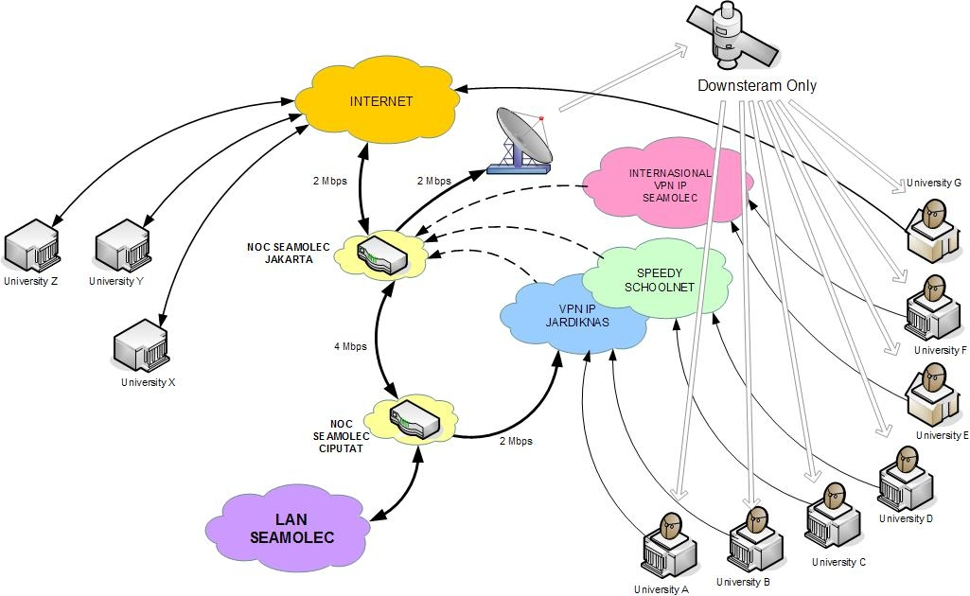

Fig. 1. Diagram of SEA EduNet
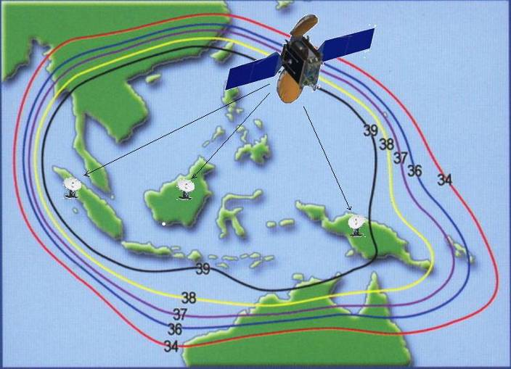

Fig 2. Footprint of Telkom 1 Satellite

Set of equipment needed by clients are as one unit of parabolic antenna (recommended: solid type, minimum size 8 ft), one set of LNB, one unit of PC as web server and router ( recommended large capacity to save/HDD), and one unit of satellite modem (DVB—S). Some pictures of the equipment are given as the following.

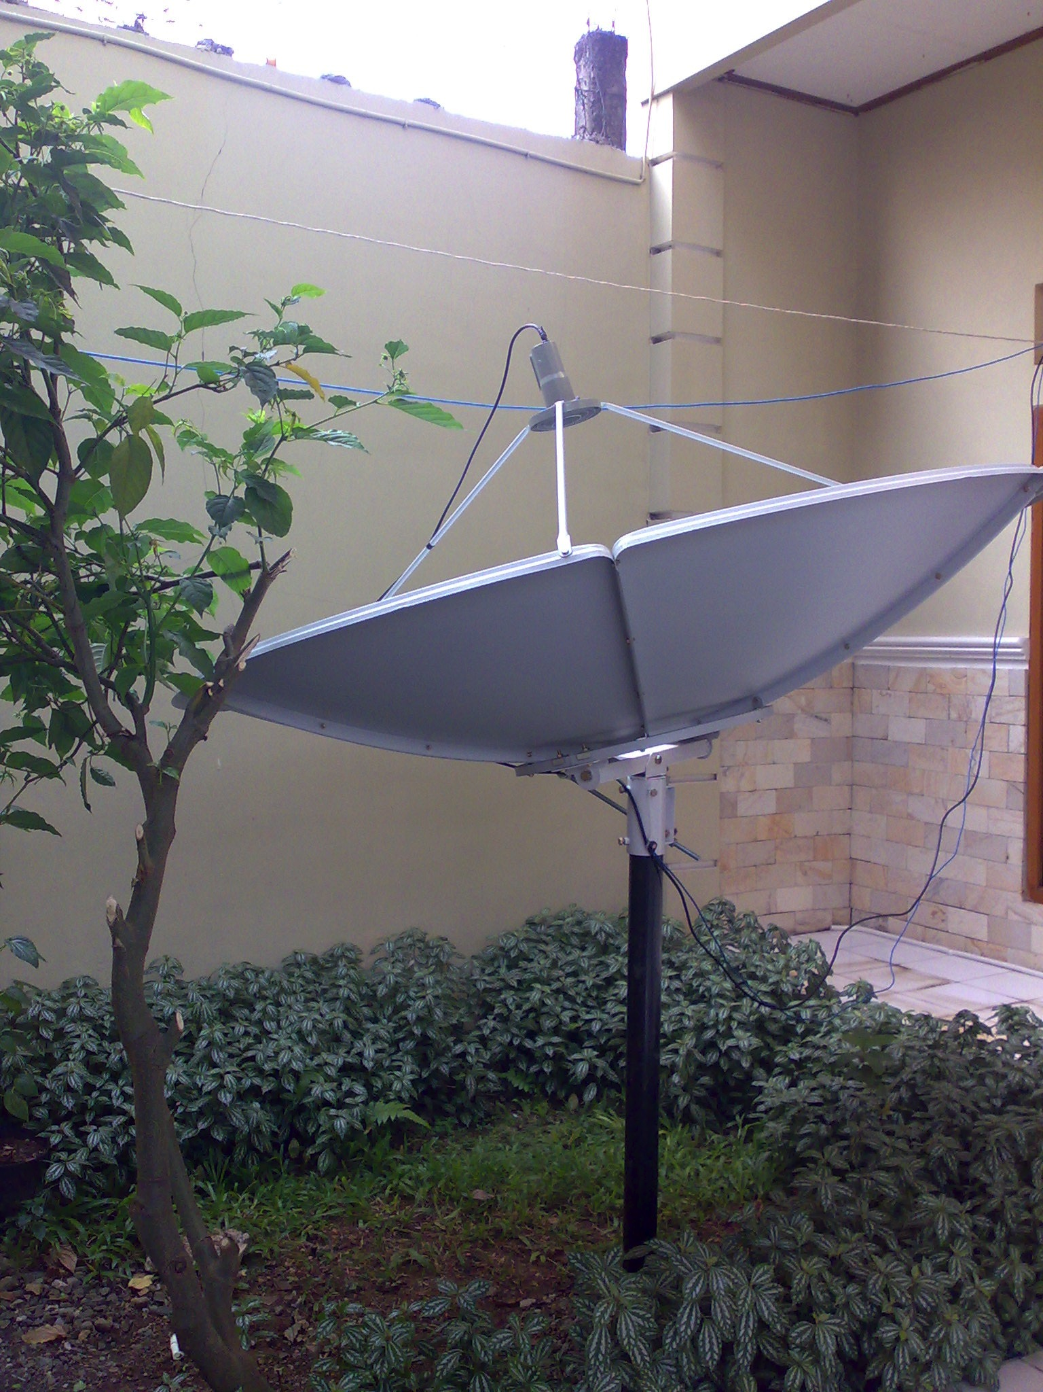

Fig. 3. Parabolic Antenna and LNB

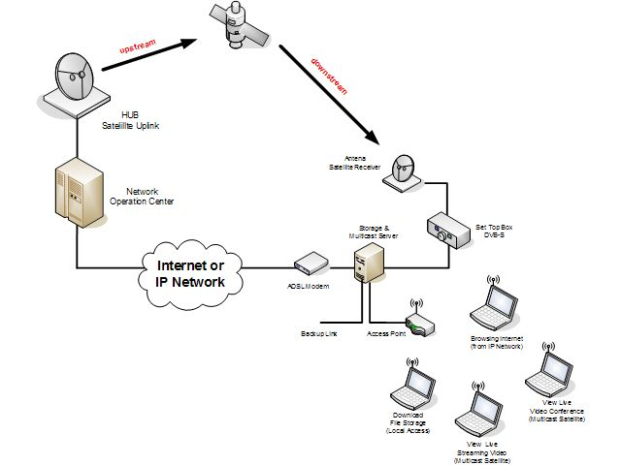

Fig 4. Scheme of SEA EduNet from the receiver side
a. The Advantages of SEA EduNet
SEA EduNet has 4 kinds of advantages. Those are for video broadcasting, Video conference broadcasting, data broadcasting/FTP mirror, and TV satellite broadcasting.

1). Video broadcasting
We have to admit that the quality of Indonesian teachers and lecturers vary.
SEA EduNet can enhance the improvement of teachers’/lectures’ competences by recording their class activities and broadcasting the records for best practice sharing. The class/lecture can be enjoyed directly on computers in the whole classroom or in the laboratory. Besides that, the records can be played and shown to the class for discussion among teachers – students for the purpose of observation and reflection.
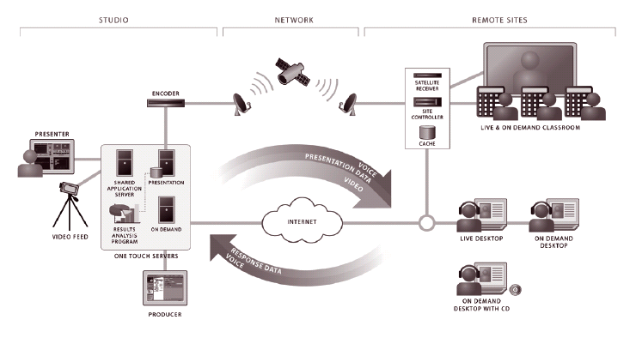

Fig. 5. Usability of SEA EduNet in classroom

2). Video Conference Broadcasting
At the moment, video conference is very common to use. One of the examples is the discussion of GEC (General Election Commission) dispute by Supreme Court in widespread areas in Indonesia. So how can this video conference seen and be benefit for other relevant receiver points in Indonesia? For instance, faculties of law of some universities or even high schools that willing to learn judicial system in Indonesia with no internet connection at all can use the benefit of video conference of SEA EduNet system.
With SEA EduNet, video conference can be directly broadcasted through satellite system, so all receiver points can follow the broadcast at the same real time. The limitation of the system is asynchronous that provides only one way communication. However, it may be adequate to meet the need of scientific aspects. Moreover, another example of the advantage of this system is to disseminate online national or regional/international seminars which directly transmit information that can be widely disseminated at that moment.

3). Data Broadcasting/FTP Mirror
E-books and multi media e-materials are widely provided in the web. In the case of Indonesia, e-books are now provided and are free to be downloaded at anytime. However, many problems were found by end users/students, such as the delivery system. When e-books are written in compact discs (CD) or flash discs, huge memories of the discs are needed, and the delivery becomes a big issue. When internet connection is used as the delivering tool, the plenty size of bandwidth is needed for which receiving schools or students do not achieve.
Using the SEA EduNet system, all data, such as training/learning video, multimedia materials, and e-books can be easily delivered directly to the target points/receiver computers without internet connection problems. Delivery is done directly from SEAMOLEC through Net Operating System (NOC) at earth/ground station and will be received by all receiver points. All the receiver points then connect to satellite multicast modem to file/web/web server which provides access through local networks.

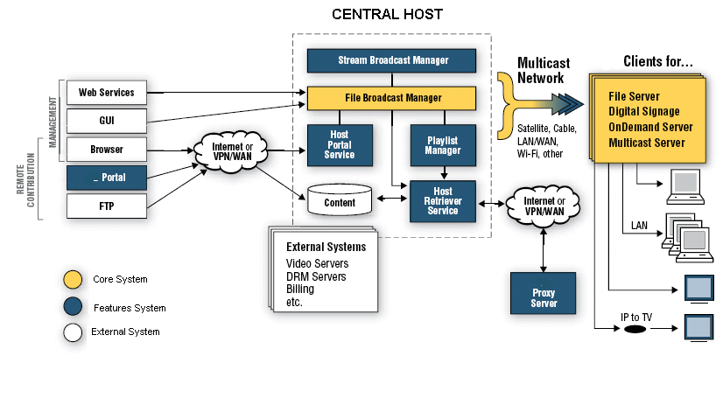

Fig 6. Diagram of Sending File Process through SEA EduNet

4). TV Satellite Broadcasting
This feature is typical advantage that differ this system from others. By connecting to TV applicant, broadcast can be enjoyed as entertainment and learning media. By subscribing to the provider of TV satellite services, this system can also receive TV broadcast services as advertised. SEA EduNet system has provided the education package which contains education video/data and selected suitable TV programs suh as: National Geographic, Discovery Channel, Animal Planet, TV-e (Indonesian TV program for education). The package is purposely provided to avoid inappropriate programs for children and students. This advantage of SEA EduNet system is not only suitable to install at the educational institutions, but also at the people’s houses.
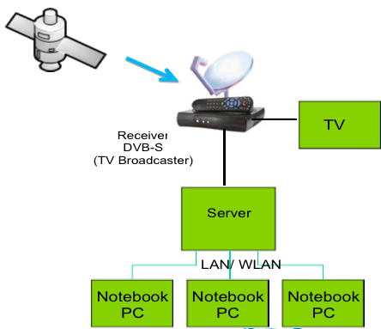

Fig 7. TV Connection using SEA EduNet

3. SEA EduNet for Education Practices in Indonesia
With the SEA EduNet system, lecturer in one location give a lecture. Many places with antene and modem and connected to SEA EduNet can receive this lecture. Students in front of their computer follow the lecturer. In case the students can not attend the lecture, they can replay the recorded-course. Interaction for this course will be done by discussion or chatting by using moodle. Students can also interact with tutors or lecturers by using e-mail.
For educational institutions which have students scatter in many areas can utilize SEA EduNet as a tool in implementing educational process. Institution need to collaborate with some other institutions in other places such as schools which have international standard, computer centers, and training centers to be its partners. These partners are functioning as class rooms which are accommodated with computer and other hardware. Students are enrolled in university and attend the course activities in its partners class rooms. All “class” activities (lecturing, exam, discussion, chatting) will happen in partners’ class rooms.
One professor can teach thousands of students. He or she gives lecture from one place and students from other places receive the lecture from their computers which are connected to SEA EduNet. Meanwhile tutors who can handle 20-25 students are ready to give their service. Tutors function as moderator, lecturer, supervisor to students. Students assignment should be read by tutor and tutor should give feedback to the students assignment. Students interact with each other (in discussion, chatting or other events such as small group in doing project) under tutors supervision.
Testing/evaluation is also administered electronically. Students go to “classroom” and take electronic testing from computer. Because of electronically, the result can be delivered automatically soon after the students finished their testing. The structure of items test can be served randomly. In this case item test in one course from one student to another student is not similar. As long as the item bank contains many items test, randomizing the items test is easy.
SEAMOLEC partners prepare classrooms, computers, internet, dish-antenna, modem for connecting antenna to computer, and other gadgets that needed for SEA EduNet. Partners should fulfill conditions in SEAMOLEC standard. This standard is developed in order to keep good quality of outcome.
By using SEA EduNet, SEAMOEC has established multicampuses to share best practices among Indonesian higher education institutions. For example, Bandung Institute of Technology (West Java) as a main campus has a study program of Masters degree in Edu-game Technology, with sub-campuses of the University of Dian Nuswatara (Central Java), SEAMOLEC (Jakarta), the Polytechnics of Art and Culture (Yogyakarta), and Vocational Education Development Center in Technology (East Java).
How about infrastructure? Building infrastructure take a lot of money. Is it possible to serve thousands or million of students without building new-infrastructure. The answer is yes and the keywords of the answer are synergy, cooperation, and collaboration (Ulman, 2006). Many educational institutions, training centers, schools with international class have already had some parts of this infrastructure. By collaboration and synergy, these institutions can build a “new” educational institution which can serve many more students.
Face-to-face universities with their partners for instance can develop “universities” with different mode of courses delivery and can serve thousands or billion of students also with good product quality. Quality can be guarded by developing right instructional designs and apply them in the right way. In term of cost, this educational business involves a lot of money. It can be imagined how much money in this business if there are thousands or million of students enrolled. Students pay less money than face-to-face universities. Lecturers and tutors also receive enough or even more than enough salary.
4. Constraints for Branding of Indonesian Educational Institutions using ODL
As developing country, Indonesia still strugle with spreading electricity to rural areas. Some areas still do net have electricity even in Java island where most people live there. Rural areas do not have chance as good as other areas, including education. Government still tries to solve this problem. In some areas, people use water or wind as a power to turn the turbin to produce electricity. Solar energy is also another way to solve electricity problem.
The cost in building new infrastructure is another problem in developing cheap but with good quality of education. If one university or school wants to develop its own infrastructure, the cost is just for their own infrastructure. But when they want to develop educational system which can receive thousands of students, this institution needs to collaborate with others as partners. By doing this they can push the need of cost. But to build the collaboration for that purpose is not easy.
The need to shift the idea of giving good quality of education from face-to-face to electronic way is important. If some educational institution have already been in the same idea, the collaboration will be easier. One institution offers some courses and other institution also offer different courses and a collection of the courses is enough to develop one study program. Certificate can be signed by some institution with each mark/stamp in it or with other way.
The cost computers, servers, the cost for internet provider or other cost will be high if an educational institution wants to develop their own system in courses delivery (centralized). Again collaboration is important not only to reduce the cost but also to be more efficient in running of educational system.
The culture could be the main problem in developing distance education. To develop enterprise-wide capabilities for sustaining distance training and education, it takes continuous effort to link project management, program management, change management, and strategic planning (Benninck, 2004; Berge & Smith, 2000; Dobbins & Berge, 2006). It is also important to realize that these changes affect the expectations, roles, and responsibilities of instructors, learners, and managers as the organization builds capacity for technologically enhanced learning of mission-critical problems.
Technology if used in proper way can be helpful for education. The need for a new approach of managing, or coaching, students so that they become more successful is highlighted by a recent report from the Sloan Consortium in which 64% of chief academic officers cite lack of student discipline as the single largest barrier to more widespread adoption of distance learning (Allen & Seaman, 2006). Self-learning needs discipline. Without discipline students will fail in their study.
C. Conclusion
With the growing number of people who need more education and with the fast development of computer technology and information technology, educational institutions can utilize these technologfy in enhancement the way they server the students. The ducational technology can also develop new way of courses delivery from face-to-face to electronic.
Collaborations among educational institution such as universities, schools, traning centers, computing centers is the best way in buliding distance education. By collaboration, the educational institutions do not need to build new infrastructure. They might be upgrading the existing tools but not necessary build the one. It is expected that more students will enrolled in DE than in face-to-face or regular schools/universities. Students will pay lower tuition fee and lecturer/tutor will receive more salary.
Barrier that face by DE Institution step by step will be reduced along the process. People understanding of DE by using electronic tools will increase. Cultural barrier is expected not be the main problem for DE anymore.
Meanwhile SEAMOLEC prepares a system to support the operation of DE with Sea EduNet. This system uses multicast system that broadcast courses like TV. Students in a certain place will receive the lecture in from of computer monitor. Interaction between students to stodents and students to tutors will be from internet by using moodle (CMS).

D. References
Allen, I. E., & Seaman, J. (2006). Making the grade:Online education in the United States, 2006. Needham, MA: Sloan Consortium.

Almala, AH (2006). Applying the Principles of Constructivism to a Quality E-Learning Environment. Distance Learning, Vol. 3, Issue 1.

Benninck, R. (2004). Implementing elearning from the corporate perspective. Retrieved September 3, 2007, from http://knowledgetree.flexiblelearning.net.au/edition05/download/Bennink.pdf

Berge, Z.L. (2007). Barriers and the Organization’s Capabilities for Distance Education. Distance Learning, Vol.4, Issue 4.

Berge, Z.L., & Smith, D. (2000). Implementing corporate distance training using change management, strategic planning, and project 13 Distance Learning Volume 4, Issue 4 management. In L. Lau (Ed.) Distance learning technologies: Issues, trends and opportunities (pp. 39-51). Hershey, PA: Idea Group.

Dobbins, B. W., & Berge, Z. L. (2006). Support for distance education and training. Distance Learning (USDLA), Vol. 3, Issue 1.

Evan, AD & Lockee,BB (2008). AT DISTANCE. An Instructional Design Framework for Distance Education. Distance Learning, Vol. 5, Issue 3.

Knapp, L. G., Kelly-Reid, J. E., & Whitemore, R. W. (2007). Enrollment in postsecondary institutions, fall 2005; graduation rates, 1999-2002 cohorts; and financial statistics, fiscal year 2005 (NCES 2007-154). Washington, DC: U.S. Department of Education. National Center for Education Statistics.

Richards, A., & Garcia, M. R. (2006). Management accounting. Concord, NH; Franklin Pierce College.

Tripp, A. (2008). Closing the Dsitance. Success Coaching for Online Education Goes Mainstream. Distance Learning, Vol. 5, Issue 1.

Ulman, C (2006). A half Hidden Asset. Distance Learning, Vol. 3, Issue 3.

Presented on International Conference: “Branding in Higher Education: Practices and Lessons Learned from Global Perspectives”, Nha Trang , Vietnam, August 9-14, 2009
Yogyakarta State University, Karangmalang, Yogyakarta and SEAMOLEC, Jakarta, Indonesia
SEAMOLEC, Jakarta, Indonesia
SMAN 1 Prambanan, Madubaru, Prambanan, Sleman, Yogyakarta, Indonesia

